PROVINCIAL GRAND CHAPTER OF ROYAL ARCH MASONS OF WEST KENT
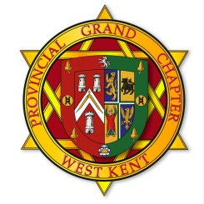
Annual Festival Dinner
Friday 8th November 2019 at 6:00 p.m.

DE VERE GRAND CONNAUGHT ROOMS
GREAT QUEEN STREET, LONDON WC2B 5DA

Menu
Wild Mushroom and Game Terrine, Tomato Chutney
- - -
Chicken Cordon Bleu
Served with Sweet Potato Fondant, Ratatouille Garlic Mayonnaise
- - -
Duo of Milk and Dark Chocolate Mousse
Please note that there is a £2 supplement for Cheese and Biscuits
as an alternative to the dessert

The cost of dinner is £47.50 per head inclusive of wine.
(or £49.50 per head if opting for cheese and biscuits as alternative to dessert)

Members and Honours recipients intending to dine should complete this form and forward it by email to Bookings@freemasons-westkent.org.uk before 18th October 2019.
Or by post to The Provincial Office, Oakley House, Bromley Common, Kent BR2 8HA

I require |  | ticket(s) for the Dinner and enclose a total remittance of £
Name
Email
Chapter |  |  | No: |  | Rank:
Guest Names |  |  |  | Dietary Requirement

Please indicate payment method below (click on relevant box)
☐ (Preferred method) By BACs using Sort Code: 20-14-33, Account No: 70738506
Please quote your name as reference.
☐ By cheque made payable to “Provincial Grand Chapter of West Kent”.
All bookings will be confirmed by email, unless a stamped addressed envelope is provided. If you do not receive your confirmation contact the Provincial Office.
Please check the confirmation and advise the Office of any errors.
I recommend that you retain a copy for your reference.

